Get single product

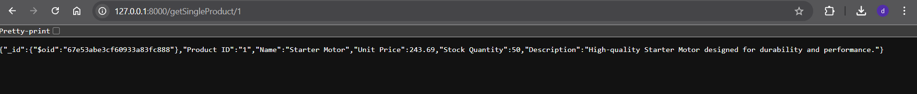

Get all

add new

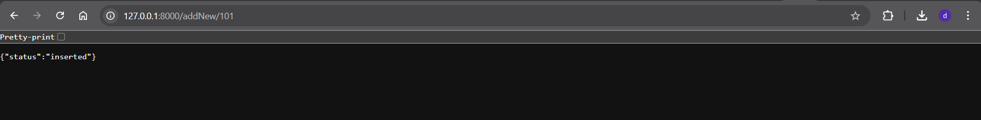

Delete One

Starts With